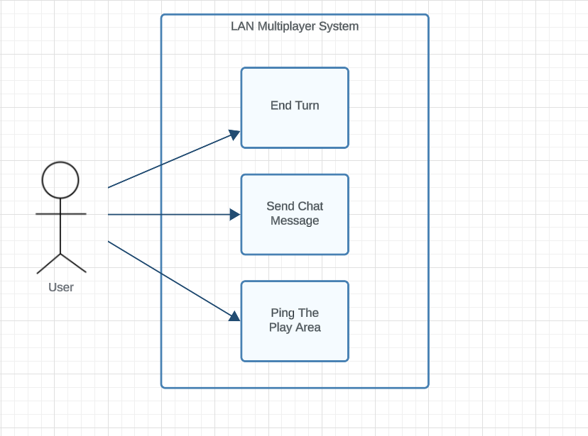

LAN Multiplayer System Model

# (Caleb)

| Title: | End Turn |
| --- | --- |
| **Description**: | When a User is done with their turn they can choose to finalize their turn and progress to next turn. |
| **System Under Design:** | LAN Multiplayer System |
| **Primary Actor**: | User |
| **Participants**: | NA |
| **Goal**: | Finish the User’s turn and begin the next turn |
| **Following Use Cases**: | NA |
| **Invariant**: | 1. User is having fun. |
| **Precondition**: | 1. Everything required to be done in a turn has been completed. |
| **Success Postcondition**: | 1. User’s turn is no longer in progress  2. Next turn is in progress |

| **User Actions**:    1. User selects “End Turn”.  3. User confirms they wish to end their turn. | **LAN Multiplayer System Responses**:  2. Offers “Are You Sure? Y/N” notification.  4. Ends User’s turn.  5. Begins next turn. |
| --- | --- |

| Title: | Send Chat Message |
| --- | --- |
| **Description**: | When a User types a message in the chat window, they can send a message to be viewable by other Users. |
| **System Under Design:** | LAN Multiplayer System |
| **Primary Actor**: | User |
| **Participants**: | NA |
| **Goal**: | The message a User types in the chat window is seen by the other Users. |
| **Following Use Cases**: | NA |
| **Invariant**: | 1. User has established LAN connection to other Users |
| **Precondition**: | 1. The message to be sent has been typed out by the User inside  the chat window. |
| **Success Postcondition**: | 1. Users can see the message sent in the chat window. |

| **User Actions**:  1. User presses “Send” button inside chat window.  3. User can view the message that has been sent. | **LAN Multiplayer System Responses**:  2. Message is posted to chat log. |
| --- | --- |

| Title: | Ping The Play Area |
| --- | --- |
| **Description**: | The User can ping a spot to display a momentary notification inside the play area for other Users to see. |
| **System Under Design:** | LAN Multiplayer System |
| **Primary Actor**: | User |
| **Participants**: | NA |
| **Goal**: | Display ping notification for all of the Users to see. |
| **Following Use Cases**: | NA |
| **Invariant**: | 1. Users are inside a game in progress. |
| **Precondition**: | 1. User’s mouse is inside the play area. |
| **Success Postcondition**: | 1. Ping is seen by all Users. |

| **User Actions**:  1. User presses the “Ping” button on their keyboard.  3. Users can see the ping at the chosen location. | **LAN Multiplayer System Responses**:  2. System displays ping notification briefly at the User’s chosen location. |
| --- | --- |

Game Turn System Model

# (Ryan)

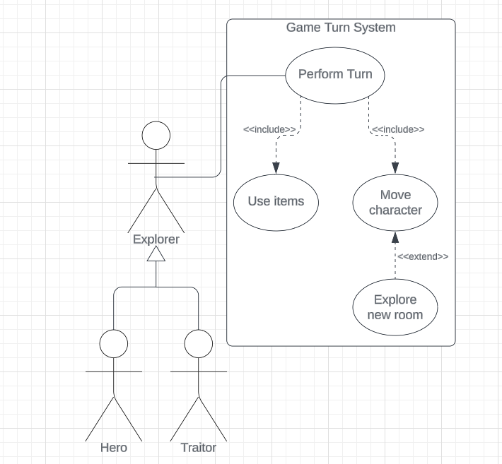

| Title: | Perform Turn |
| --- | --- |
| **Description**: | The explorer can perform all turn-specific actions to control their character in-game |
| **System Under Design:** | Game Turn System |
| **Primary Actor**: | Explorer |
| **Participants**: | Hero and Traitor |
| **Goal**: | Control the character to traverse the haunted house and interact with any aspects of the board |
| **Following Use Cases**: | Includes “Use items” and includes “Move character” |
| **Invariant**: | N/A |
| **Precondition**: | The explorer is still alive  The turn queue has reached the current explorer’s index/turn |
| **Success Postcondition**: | The character model moves and acts upon the explorer’s input |

| **User Actions**:  2) User performs a turn action  4) User can see the outcome of their previous action | **Game Turn System Response**:  1) System begins the explorer’s turn  3) The character model performs action for all players |
| --- | --- |

| Title: | Use Items |
| --- | --- |
| **Description**: | The explorer selects an item in their inventory to use or consume |
| **System Under Design:** | Game Turn System |
| **Primary Actor**: | Explorer |
| **Participants**: | Hero and Traitor |
| **Goal**: | Use the effects of the interacted item |
| **Following Use Cases**: | Included in the “Perform turn” |
| **Invariant**: | It is the current explorer’s turn |
| **Precondition**: | The explorer has the item in their inventory |
| **Success Postcondition**: | The explorer’s character or environment gets affected by the item’s effects |

| **User Actions**:  1) User clicks item  3) User confirms usage of the item  5) User sees the outcome of the item’s effects | **Game Turn System Response**:  2) Displays full item description  4) Affect character or environment with the item’s effects |
| --- | --- |

| Title: | Move Character |
| --- | --- |
| **Description**: | The explorer selects a room tile to move their character into |
| **System Under Design:** | Game Turn System |
| **Primary Actor**: | Explorer |
| **Participants**: | Hero and Traitor |
| **Goal**: | The character is moved to the selected room tile |
| **Following Use Cases**: | Included in the “Perform Turn”  Contains an extension to “Explore new room” |
| **Invariant**: | It is the current explorer’s turn |
| **Precondition**: | The explorer has not consumed all their available movement |
| **Success Postcondition**: | The explorer’s character moves into the selected room tile |

| **User Actions**:  1) User clicks room tile  3) User confirms movement to location  5) User sees their character in the new location | **Game Turn System Response**:  2) Displays detailed view of the room  4) Visually displays character movement to target location |
| --- | --- |

| Title: | Explore Room |
| --- | --- |
| **Description**: | The explorer can explore a new room through an open doorway of another room tile |
| **System Under Design:** | Game Turn System |
| **Primary Actor**: | Explorer |
| **Participants**: | Hero and Traitor |
| **Goal**: | The new room is revealed and connected to the previous room tile. The character enters the room, and any effects of the new room are cast on the character. |
| **Following Use Cases**: | Extension of “Move Character” |
| **Invariant**: | It is the current explorer’s turn |
| **Precondition**: | There is no previous room in the current tile  There are available room tiles for the current floor |
| **Success Postcondition**: | A new room is placed and the character enters into it |

| **User Actions**:  1) User moves into open doorway  2) User sees the new room and its effects on their character | **Game Turn System Response**:  2) A random new room tile is selected and placed into the board |
| --- | --- |

**Game Settings Model**

**(Ethan)**

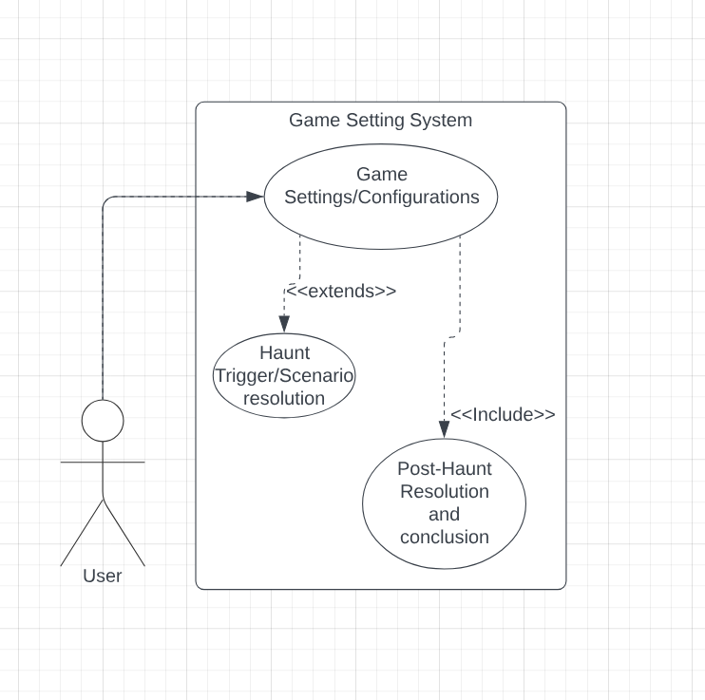

| Title: | **Game Settings Configuration** |
| --- | --- |
| **Description**: | Within the game settings framework, players configure their preferred options before starting a session. They adjust settings such as difficulty level, game mode, and communication preferences. The game settings system provides a customizable experience, allowing players to tailor the game to their preferences. It ensures that players have control over their gameplay experience. This use case extends the next use case of Haunt Trigger/Scenario resolution as the settings for the haunt trigger/scenario resolution will be a part of the game settings and configurations. |
| **System Under Design:** | Game Settings System |
| **Primary Actor**: | User |
| **Participants**: | NA |
| **Goal**: | To configure game settings according to player preferences before starting a session. |
| **Following Use Cases**: | Haunt Trigger and Scenario Resolution, Post-Haunt Resolution and Conclusion |
| **Invariant**: | The game settings system should accurately reflect the selected options throughout the session |
| **Precondition**: | The player must be logged in and preparing to start or join a game session |
| **Success Postcondition**: | The game settings are configured according to the player's preferences, and the session is ready to begin |

| **STEPS**:   1. The player accesses the game settings menu before starting or joining a session. 2. The player selects options such as difficulty level, game mode, and communication settings 3. The player confirms their selections, and the game settings are updated accordingly. | **ALTERNATIVES**:   * If the player changes their mind, they can adjust the settings before confirming. * If the game system encounters an error in applying the settings, it informs the player and allows them to try again |
| --- | --- |

| Title: | **Haunt Trigger and Scenario Resolution** |
| --- | --- |
| **Description**: | As part of the game settings framework, the game system monitors the session parameters and triggers the haunt phase when specific conditions are met. During the haunt phase, the game system guides players through the scenario, ensuring a cohesive and immersive experience. The game system will guide the user based on the game settings and configurations that were set prior to starting the game. |
| **System Under Design:** | Game Settings System |
| **Primary Actor**: | User |
| **Participants**: | NA |
| **Goal**: | To trigger the haunt phase and guide players through the resolution of the selected haunt scenario. |
| **Following Use Cases**: | Game Settings Configuration, Post-Haunt Resolution and Conclusion |
| **Invariant**: | The haunt trigger conditions are accurately monitored, and the selected haunt scenario corresponds to the established game settings. |
| **Precondition**: | The session settings are configured, and the players have completed the exploration phase |
| **Success Postcondition**: | The haunt phase is initiated, and players are provided with their respective roles and objectives for the selected scenario |

| **STEPS**:   1. The game system continuously monitors session parameters and haunt trigger conditions. 2. When the required conditions are met, the game system initiates the haunt phase. 3. The game system selects a haunt scenario based on the established game settings. 4. Players are informed of their roles and objectives for the haunt scenario. 5. The game system provides guidance and resolves actions throughout the haunt phase. | **ALTERNATIVES**:   * If there is an error in selecting the haunt scenario, the game system notifies the players and allows for correction. * If players disagree with the selected haunt scenario, they can discuss and potentially choose an alternative scenario before proceeding. |
| --- | --- |

| Title: | **Post-Haunt Resolution and Conclusion** |
| --- | --- |
| **Description**: | The game settings system provides options for starting a new session, adjusting settings, or concluding the gameplay experience. It facilitates a smooth transition from the haunt resolution to post-game activities, ensuring that players have control over their gameplay experience. This use case is listed as an <<include>> as it will be a separate part of the game settings by recalling back to the menu if the user needs to change settings post game. |
| **System Under Design:** | Game Settings System |
| **Primary Actor**: | Player |
| **Participants**: | NA |
| **Goal**: | To reflect on the haunt experience, review game settings, and make decisions for future sessions. |
| **Following Use Cases**: | Game Settings Configuration, Haunt Trigger and Scenario Resolution |
| **Invariant**: | Player decisions for future sessions are accurately reflected in the game settings system. |
| **Precondition**: | The haunt phase has concluded, and players are ready to reflect on their experience. |
| **Success Postcondition**: | Players have made decisions for future sessions, and the game settings are updated accordingly. |

| **STEPS**:   1. Players discuss the events of the haunt and reflect on their experience. 2. Players review the current game settings and consider any desired adjustments. 3. Players make decisions for future sessions, such as starting a new game or continuing with the current settings. 4. The game settings system updates the session parameters and prepares for the next session based on player decisions. | **ALTERNATIVES**:   * If players cannot agree on future session decisions, they may opt to discuss further or defer the decision to a later time. * If there are technical issues with updating the game settings, the system notifies the players and provides guidance for resolution. |
| --- | --- |